Abdull Haseeb
SU92-BSAIM-F24-050
BSAI-3A
LAB NO 12

Project Documentation – Bank Marketing Prediction (Flask + ML Model)
1. Project Overview
This project is a Flask-based web application that predicts whether a bank customer will subscribe to a term deposit.
The prediction is made using a pre-trained Machine Learning model and a data scaler, both loaded from saved files.
The user interacts with a frontend form (HTML) where they enter customer information.
The backend (Flask app) processes the input, applies scaling, makes a prediction, and displays the result. 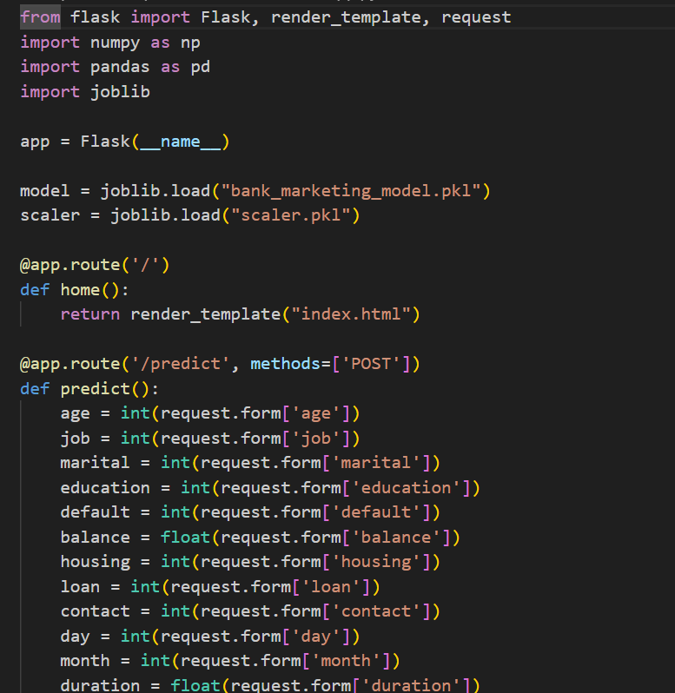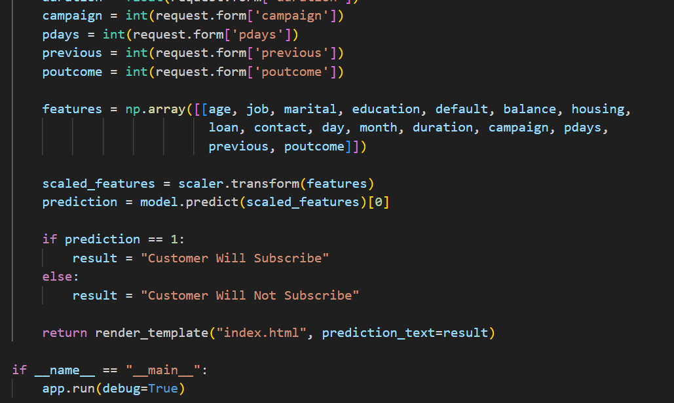

2. Main Components
2.1 Flask Application
A Flask app is created as the main backend server. It handles:
- Loading the ML model
- Loading the scaler
- Rendering the frontend page
- Receiving form data
- Producing predictions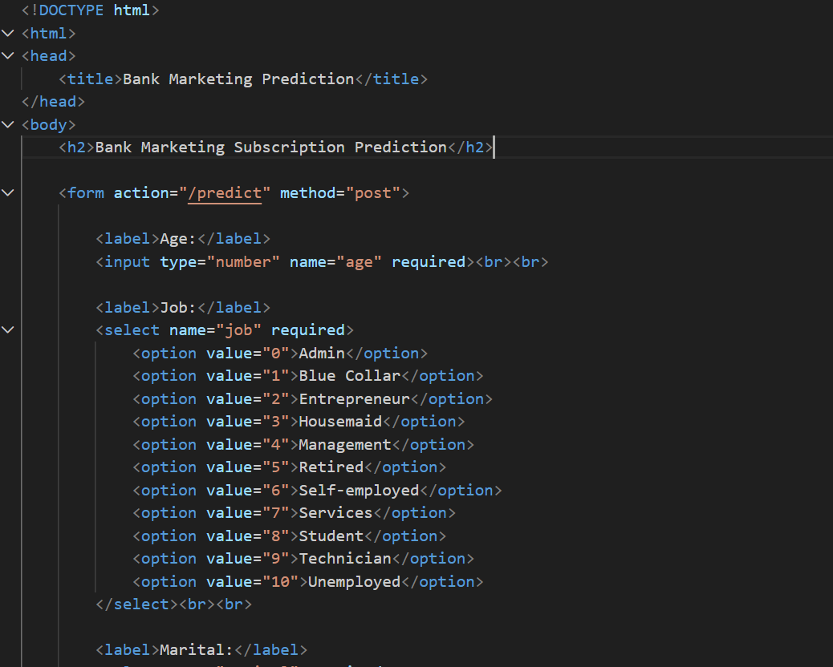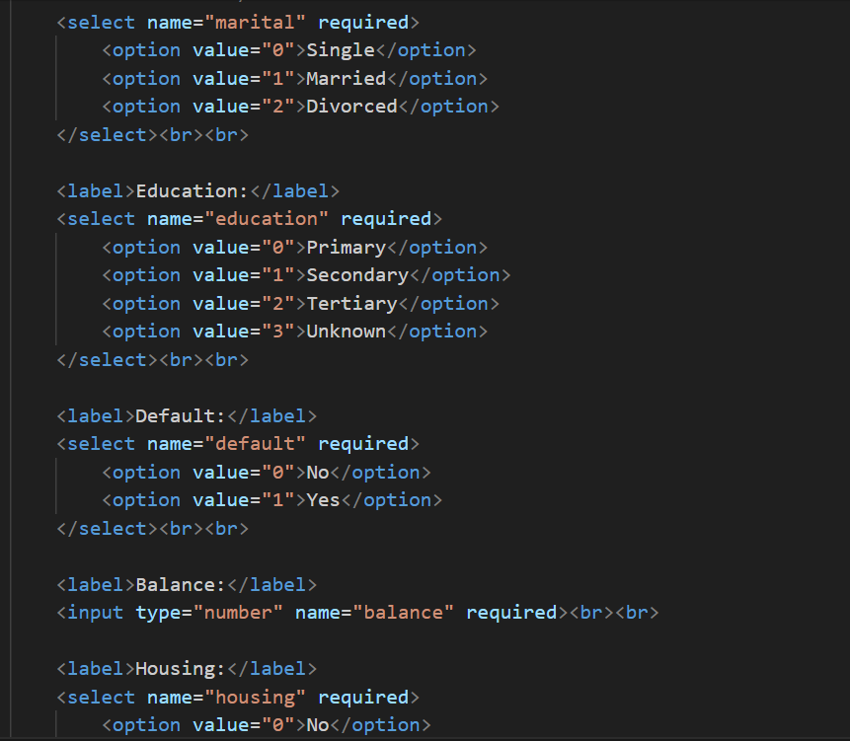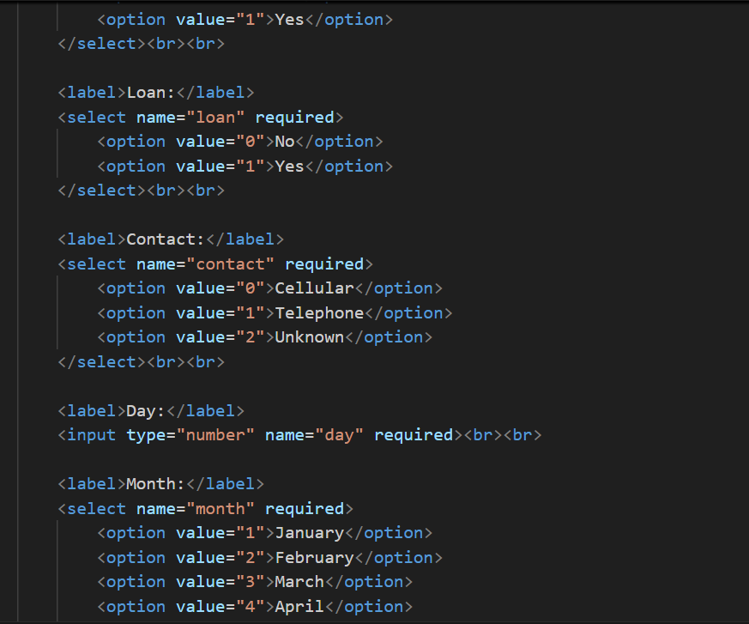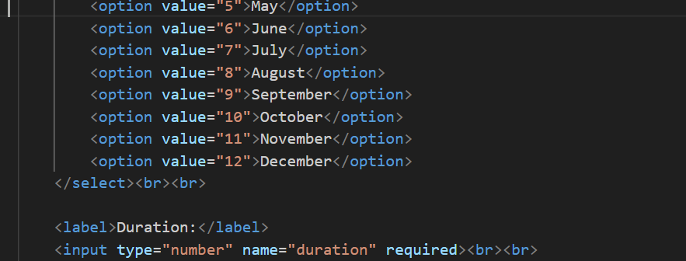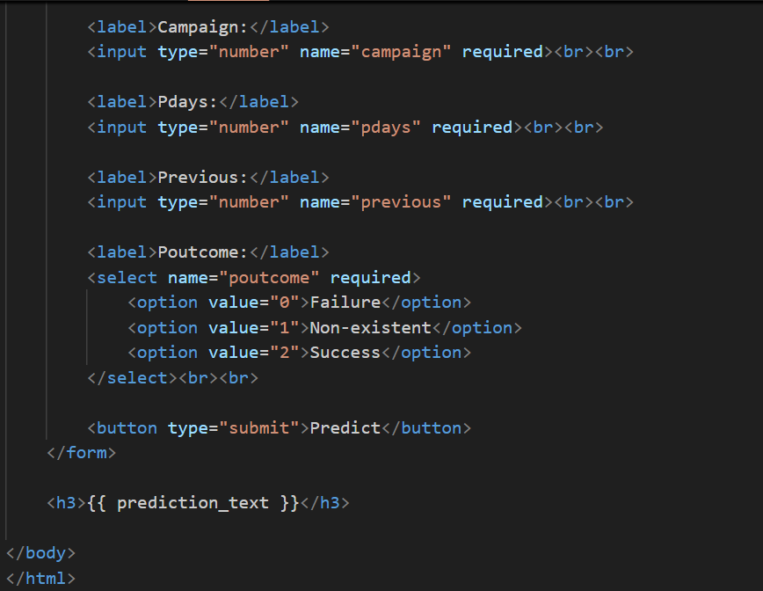

2.2 Loaded ML Assets
The app loads two files:
- bank_marketing_model.pkl
Pre-trained statistical or ML model used to make predictions.
- scaler.pkl
A fitted scaler used to normalize or standardize numeric inputs before prediction.
These files ensure the Flask app can perform predictions exactly the same way as during model training.

3. Application Routes
3.1 Home Route (/)
- Displays the index.html page.
- This is where the input form exists.
- No prediction happens here.

3.2 Prediction Route (/predict)
This route:
- Receives form data sent via POST method.
- Converts each input into numeric format (integer or float).
- Combines all inputs into a single NumPy array in the correct model feature order.
- Uses the scaler to transform the input.
- Sends the scaled data into the model to get a prediction.
Prediction Logic
- If prediction = 1 → "Customer Will Subscribe"
- If prediction = 0 → "Customer Will Not Subscribe"
The result is then displayed back on the same page (index.html) using a template variable.

4. Input Features
The model expects the following fields (all collected from the HTML form):
Feature | Description
age | Customer age
job | Encoded job category
marital | Marital status (encoded)
education | Education level
default | Has credit default?
balance | Bank account balance
housing | Housing loan status
loan | Personal loan status
contact | Contact communication type
day | Last contact day
month | Last contact month
duration | Last call duration
campaign | Number of contacts during the campaign
pdays | Days passed after previous contact
previous | Number of previous contacts
poutcome | Outcome of previous marketing campaign
All inputs are numeric because the model expects encoded integer/float values.

5. Data Processing Workflow
- User enters information in the form.
- Flask receives and converts inputs.
- Inputs are combined into a feature vector.
- Scaler transforms the raw values to scaled values.
- Model predicts subscription probability.
- Result is displayed on the web page.

6. Running the Application
When running the file directly:
- Flask starts in debug mode
- The app becomes accessible locally (usually at http://127.0.0.1:5000)
Debug mode helps development by showing detailed error messages and auto-reloading on code changes.

7. Summary
This Flask app provides a simple and effective interface for bank marketing prediction.
It connects the following components:
- HTML frontend form
- Flask backend
- Scaler + ML model
- Result rendering

